**PERSONALIZED INVITATION**

***INTRODUCTION:***

***OVERVIEW:***

I am writing to invite you to a one-on-one meeting on date at time. The Purpose of this meeting is to review.If this time and date do not work for you, please let me know so that we can reschedule. I look forward to meeting with you.

***PURPOSE IN PERSONLIZED INVITATION****:*

Invitation letters are letters sent to some one to invite them to a specific event. The major goal of writing invitation letters is to plan the number of guests who will arrive a few days before the event. An invitation letter allows the host to better manage the event by allowing them to make appropriate arrangements.

***PROBLEM DEFENITION AND DESIGN THINKING:***

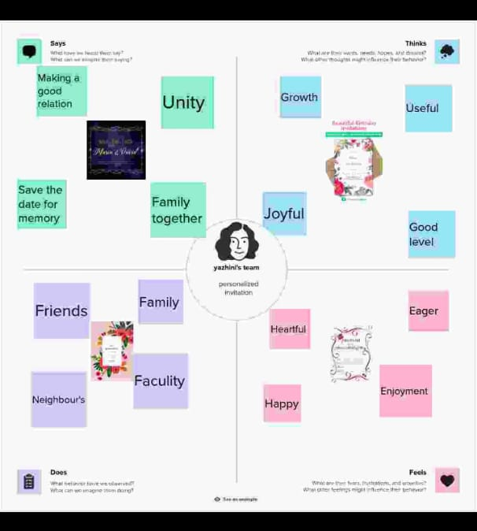

***IDEATION AND BRAINSTORMING MAP:***

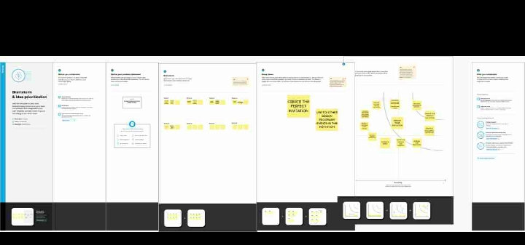

***RESULT:***





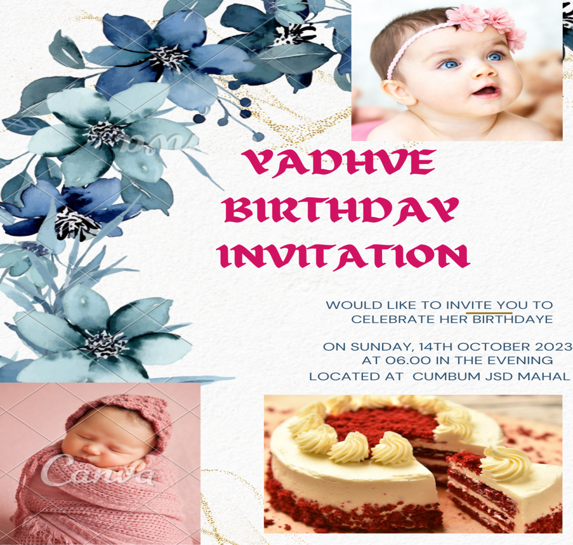

***ADVANTAGES OF PERSONALIZED*** ***INVITATION***:

* Makes your guests feel special
* Sets the tone for your event
* Allows you to be specific about who is actually invited.
* Guest list is private
* Have confidence in the assurance of delivery.
* Received more formal RSVP s

***DIS ADVANTAGES OF PERONALIZED INVITATION:***

* Invite who are not tech lack the gadgets means to receive save such invitation will not know about the invitation.
* Those who like to save the invitation as a souvenir.
* Online messages seem cold and lacks the sentimental aspect of a nicely decorated actual invite. I analogize it to like what the recipient will do with the invitation.

***APPLICATIONS:***

One of the widely used apps to design online invitations for any occasions has to be canva. Best known for photo editing and video editing, the application is widely used by people to prepare graceful posts across all social media platforms.

***CONCLUSION:***

An invitation to offer becomes a contract only when the seller extends an offer to the buyer. The key distinction lies in the term invitation. It signifies an invitation to any potential buyer to make an offer for the goods or services sold.

***FUTURE SCOPE:***

* Name of host
* Invitational ( requests the pleasure of your company , cordially invites you to )
* Event purpose
* Date
* Hour
* Place
* Reply instructions ( eg , reply card or phone number )
* Disabled instructions ( eg , fax or email )